IBM SkillsBuild Enrollment Process Guide- Software Development

What is IBM SkillsBuild
IBM SkillsBuild is a free digital education platform developed by technology experts that offers skills-based learning for students, adult learners, and faculty regardless of where they are in their career journey. The platform provides access to over 1,000 online courses focused on technology and workplace skills, allowing users to develop valuable new competencies in high-demand fields. Upon completion of courses, learners can earn digital credentials to demonstrate their achievements to potential employers, helping to build pathways toward entry-level employment in the tech industry.

Why Per Scholas and IBM is Bringing This Opportunity to You!
Per Scholas is proud to partner with IBM SkillsBuild to empower the next generation of technologists. Our shared mission is to drive economic mobility and create inclusive pathways into high-growth tech careers. Per Scholas's rigorous programs, combined with IBM SkillsBuild's vast resources and industry-recognized digital credentials, directly address the urgent need for skilled tech talent. Together, we are equipping individuals with the in-demand skills, professional development, and employer connections necessary to thrive in the evolving digital landscape, fostering a more equitable and skilled workforce.

Registration and Program Onboarding
As a Per Scholas Software Development learner you are REQUIRED to enroll in the learning path Per Scholas created for you.

If you are enrolled in one of our following courses, you must complete the enrollment process by the end of week two of your training!

- Full Stack Software Development - MERN
- Full Stack Java Development

We will also remind you through your cohort slack channel to ensure you have completed the enrollment process!

1. Platform Registration
Please register for Skillsbuild using this Self-enroll link. You are encouraged to sign up with Linkedin or Google.

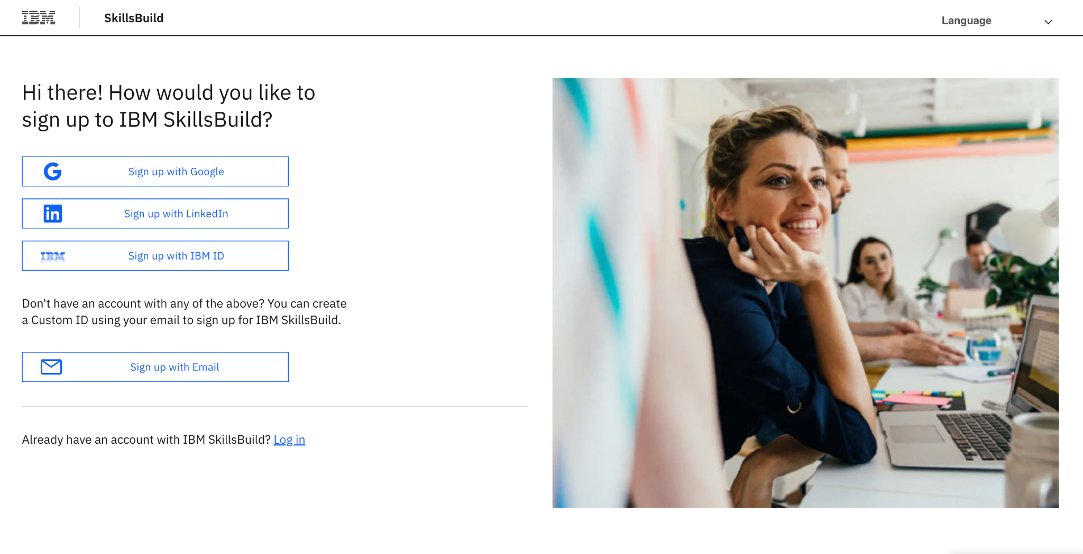

2. Learning Path Enrollment
After you register please enroll in the pathway. Click “Enroll” to complete the process.

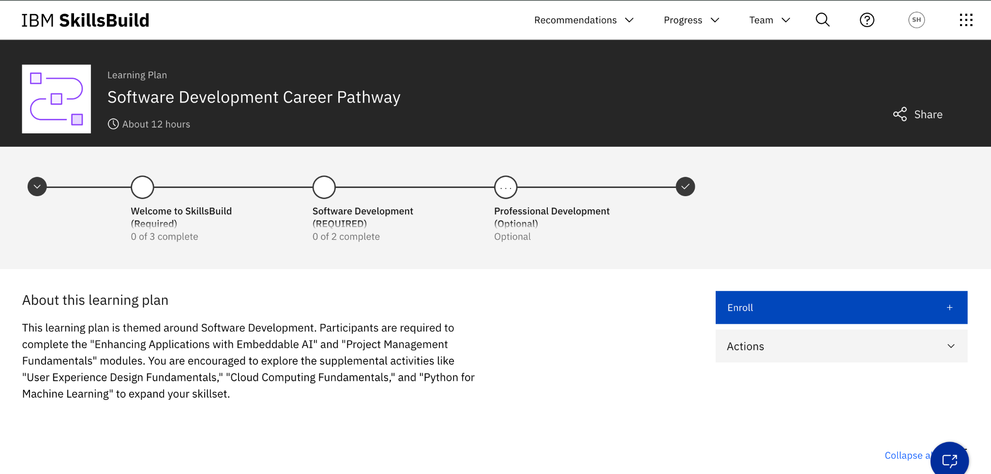

3. Begin learning!

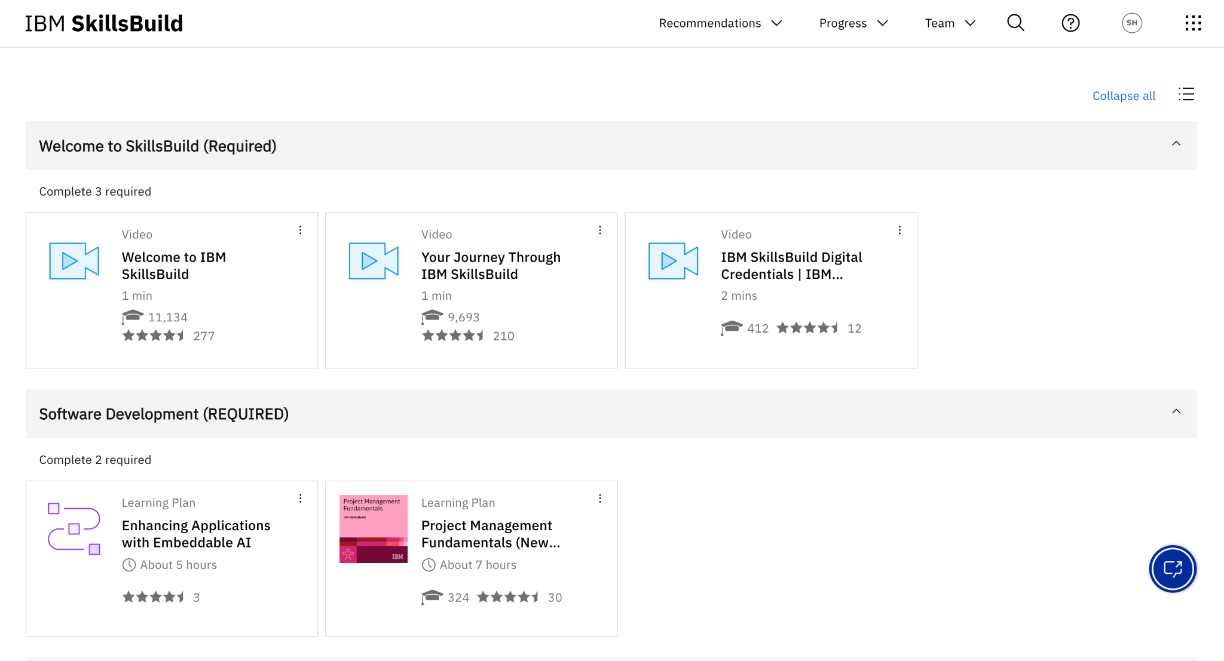

4. Viewing Progress

From the home page select progress.
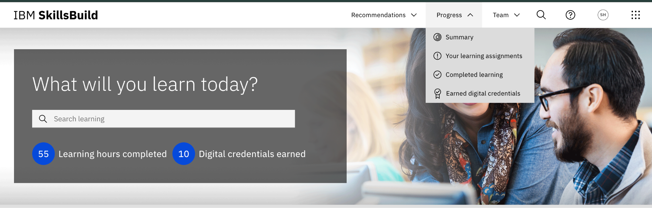

Summary: Provides a snapshot of learning assignments, learning hours completed & digital credentials earned.
Your learning assignments: View all assigned learning activities & their progress.
Completed learning: View and download all completed assignments & digital credential.

5. Road to Completion and More!

Continue your learning journey with the Software Development learning path throughout your Per Scholas experience and beyond! Upon completion, leverage the extensive resources of IBM SkillsBuild and our curated alumni course offerings to further your skills and career growth.

